OVLP/SRP Academic Year 2025-26
Duration: May 4 - 8, 2026 |  |  | Grade: Pre-Nursery |  | Subjects: All
Term III |  | Week: 10
 | English | Urdu |  | Math |  | HCD | IT
Links | class story  The Dark Forest The Little Firefly  https://drive.google.com/file/d/1L9pUorlMogVSLUpbl2MxG3qFKdzqsfCA/view?usp=sharing  The Kind Farmer and the Clever Cow  https://drive.google.com/file/d/1PjpGDXqaMBzFycjlhqpkM_y4mYPm-Kwf/view?usp=sharinghttps://drive.google.com/file/d/1E9nn06oTZmG5JdwT-OMxHq92mFjp7-p1/view?usp=share_link  Fill in the blanks.  https://drive.google.com/file/d/18DetciB0yhDxiPE3w5XBOUX-RXOlmzx5/view?usp=share_link  Write the first letter of the pictures.  https://drive.google.com/file/d/1BvTckndwBhcIcF2g-Ezd7d6GPwBAXynO/view?usp=sharing  what comes next?.  https://drive.google.com/file/d/1tg-NgiYyqchDIDpiIao7HMMQkkdbFH2h/view?usp=sharing  Match the letter with the picture.  https://drive.google.com/file/d/1DZlQpEN2sXlJO7rAi9eYQWnIocaCHuRr/view?usp=sharing  Sequencing  https://drive.google.com/file/d/1z7l-i_NWLBAWE3p_vxy5WzdcadJPlA4v/view?usp=share_link  Circle the correct letter of the picture.  https://drive.google.com/file/d/18DetciB0yhDxiPE3w5XBOUX-RXOlmzx5/view?usp=share_link | Class story  Murghi or chiriya  https://drive.google.com/file/d/1l1Gdko6TYpm5cb6e8JHlenTX2PK9_s5h/view?usp=sharing  Bhalu ka bacha  https://drive.google.com/file/d/1ncUv2pL3RmwAOLrY5lHQ84rCgscjfDzj/view?usp=sharing  Ont or Saya  https://drive.google.com/file/d/1kickcOMQo0xpV-bJFEhDATb68gkuEENC/view?usp=sharinghttps://drive.google.com/file/d/1bf6tuus5tXKZ4LyKMzh4iDJ99lf5Dyzr/view?usp=sharing  Drust harf k gord dayra lagayen.  https://drive.google.com/file/d/1fnDgL9-hwGd9UcX3apUWeD57INEgwTxG/view?usp=share_link  Agla harf likhen  https://drive.google.com/file/d/1qvLhZklqcgLj0IvhETHFKy5Eav6170Is/view?usp=share_link  haroof ko tasaveer sy milayen  https://drive.google.com/file/d/1SbUnK0OnQZU8c9zgpnZWGmOi0WDhcQ3f/view?usp=share_link |  | Write the first letter of the shapes  https://drive.google.com/file/d/1jbHkyS-QQi2RUKvIosQxYf_Yn7wJavm0/view?usp=share_link  Draw acoordingly  https://drive.google.com/file/d/1wu6R8XPkFo3Xp12WP_ZpwQ_4yZlk2GYA/view?usp=share_link |  | P.N TIIISRP10 | Week 10 OVLP Grade Pre-Nursery IT Term 3.mp4
Day 1  C.W | - Fill in the blanks(a-w).  - Write the first letter of the pictures(a-e).  - Note book pg. # 42 | 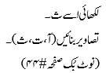 |  | Revise numbers 1- 4 |  | Pupils will learn about Sharing/ Vegetables
Home work | - Writing a-z.  - What comes next? (a-m)  - Match the letters with the pictures(a-e).  Note book pg. # 43-44 | ____________ |  | _____________ |  | --------
Day 2  C.W | Revise f-j | 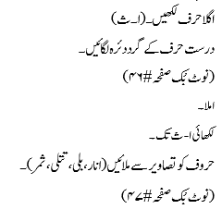 |  | - Counting (0 - 10).  - Write the first letter of shapes (circle, cone, diamond, triangle)  - Note book pg. # 34 |  | Pupils will learn about “White Butter”.
Home work |  | 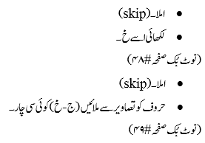 |  | _____________ |  | ---------
Day 3  C.W | - Sequencing(a-e).  - Draw pictures (a, b, c, d) one picture with each letter.  - Note book pg. # 45 | 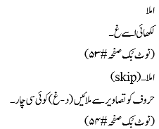 |  | - Counting (10 - 20).  - Tick the few objects and color the more objects.  - Note book pg. # 35. |  | Pupils will be playing Zig Zag races.
Home work | _____________ |  |  | - Counting (0 - 20)  - Note book pg. # 36. |  | ------------------------
Day 4  C.W | - Dictation  - Circle the correct letter of the picture (banana, dolphin, flag, hat ).  - Note book pg. # 46 | 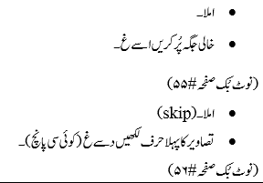 |  | Workbook pg. # (79). |  | Oral Questions and Answers:  Q.1: What is the national language of Pakistan? Ans: Urdu is the national language of Pakistan.  Q.1: Which Dua do we say when we go upstairs. We say “ALLAHU AKBAR” when we go upstairs.  Q.1: Tell the names of 5 vegetables. Ans: Tomato, Potato, Carrot, Radish and Onion.
Home work |  |  |  |  |  | ---------
Day 5  C.W | - Dictation.  - Fill in the blanks (n-z).  - Note book pg. # 47 | حرف ص ۔غ کی لکھائی |  | - Dictation.  - Counting (20 - 25)  - Draw accordingly (6) Page 37 |  | The revision of all the previous work done this week is complete.
Home work

